Data Analytics With Tableau

Name : N. Syam Surya
Team Member – 3 Assignment - 2

Supermarket Sales Data Analysis Report – Tableau Visualizations

- Donut Chart – Sales by Product Line

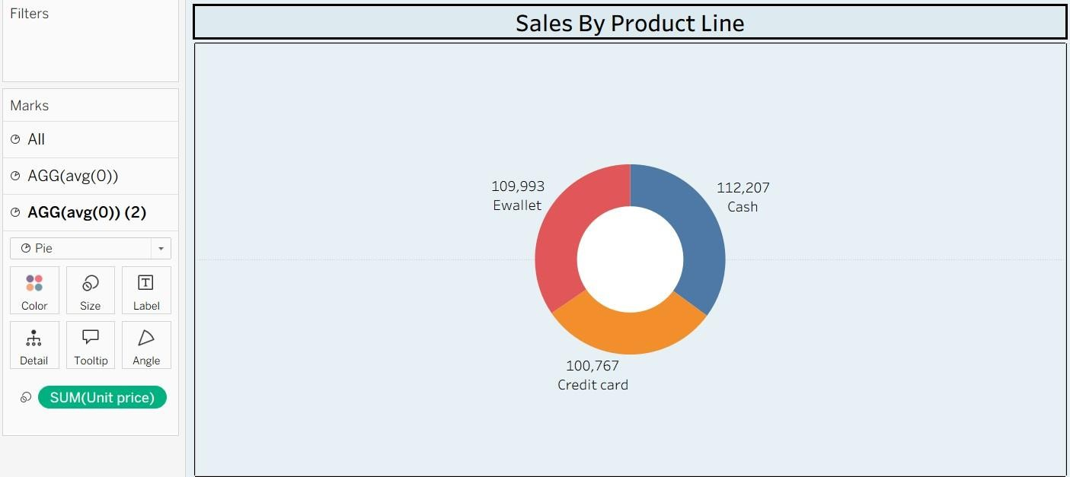

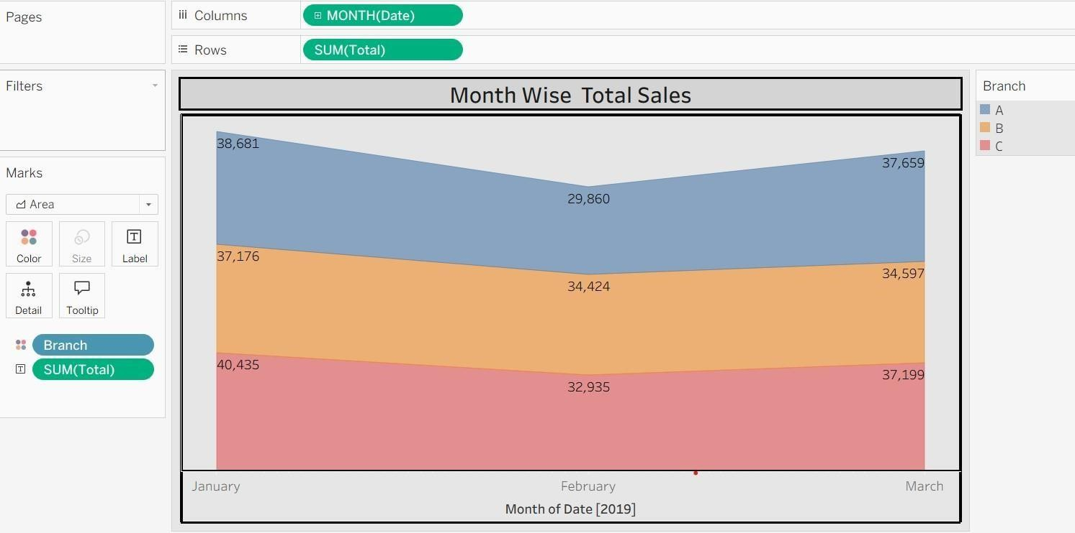
- Chart – Sales by Product Line

- Text Table – Branch, City & Product Line

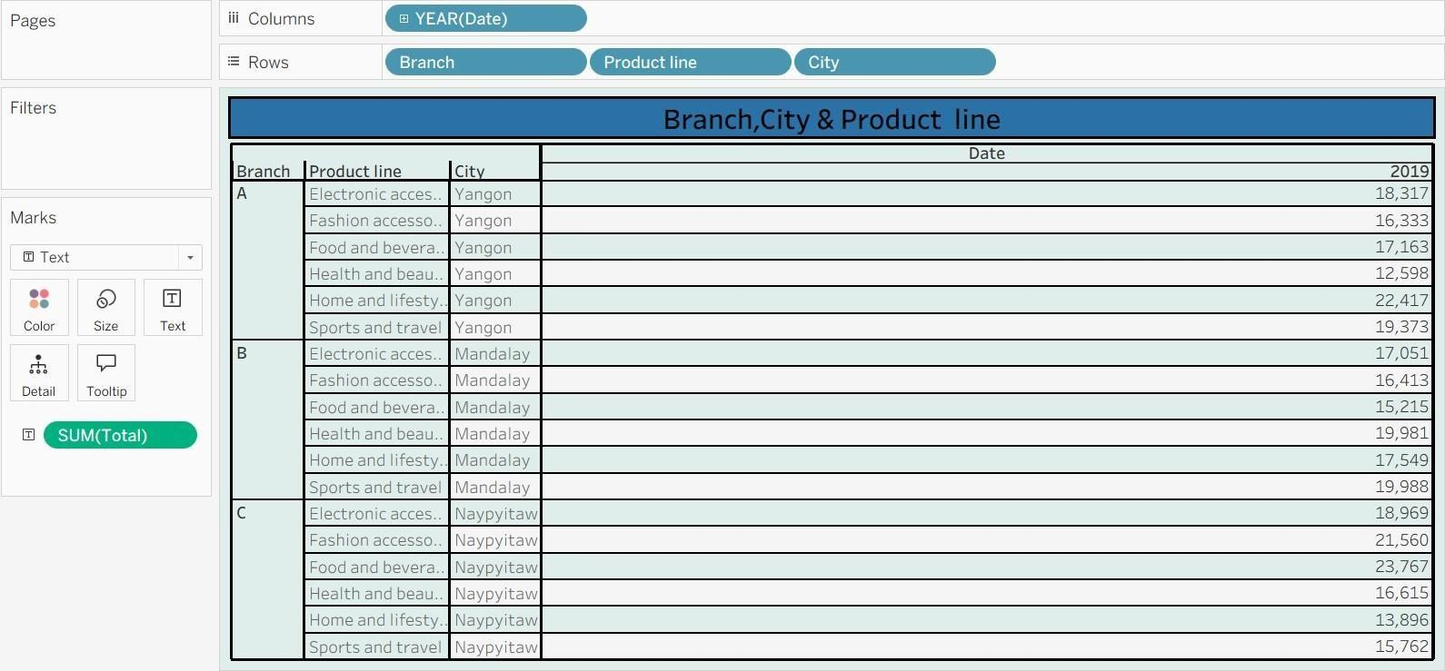

- Highlighted Table – Branch Wise Sales by Product Line

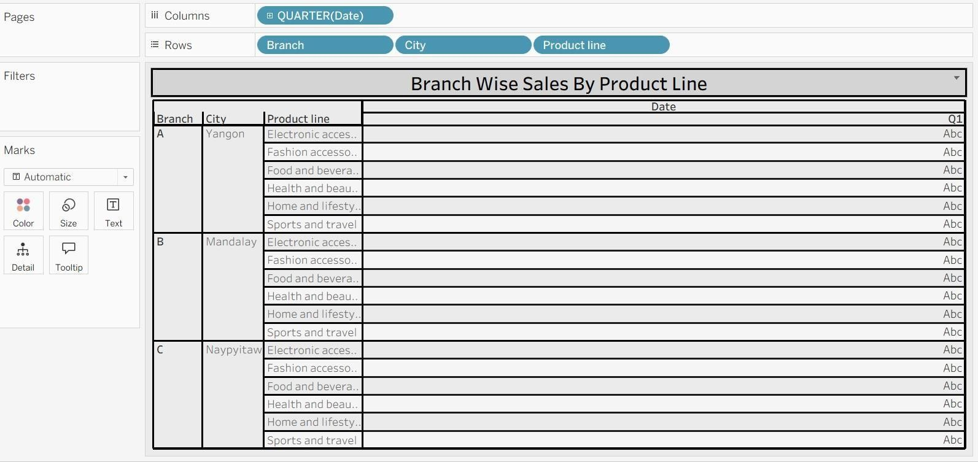

- Word Cloud – Top Product Lines by Sales

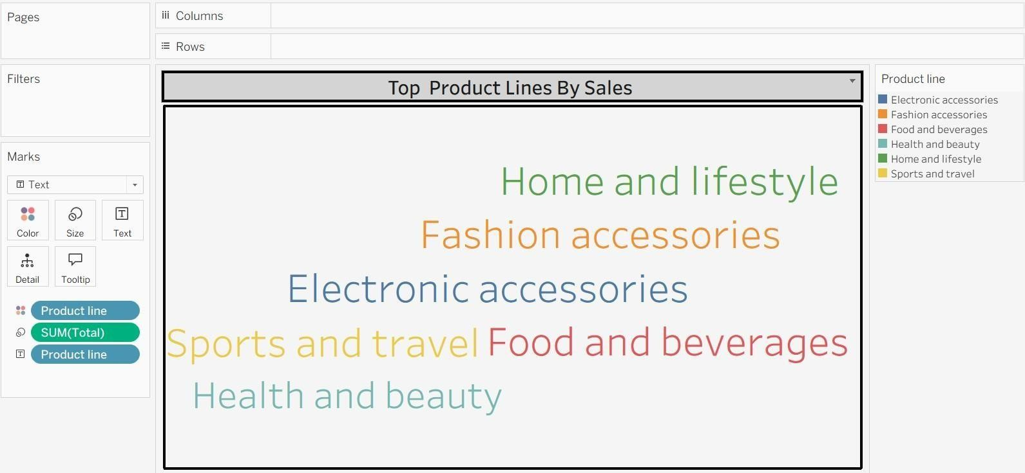

- Funnel Chart – Total Sales by Product Lines

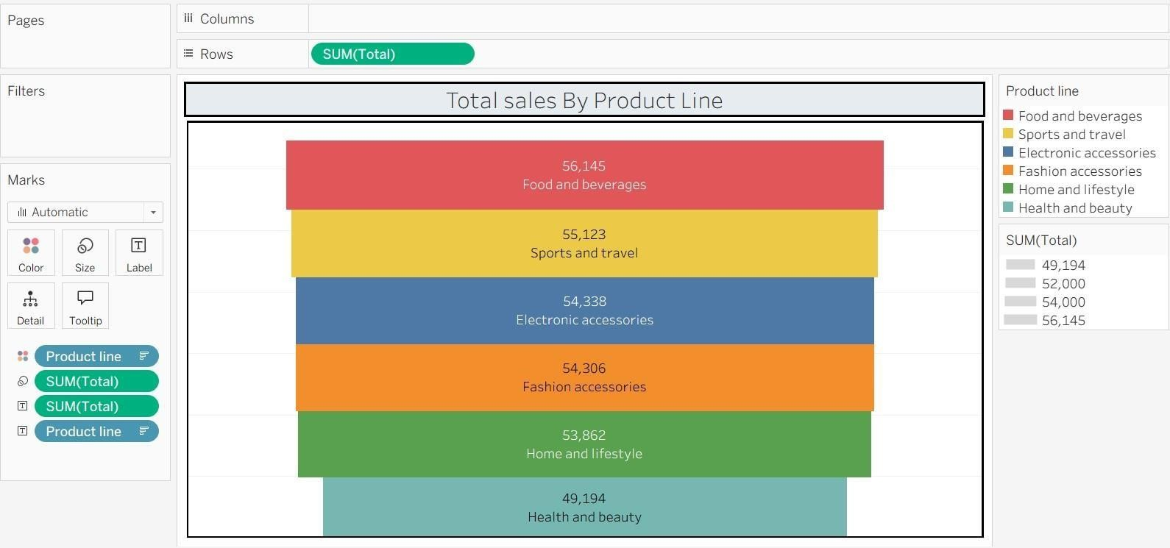

-
- Waterfall Chart – Total Sales Contribution by Product Line

